**SAFRIZAL RAHMAN**

**19**

**SIB 2G**

**234176015**

**JOBSHEET 2**

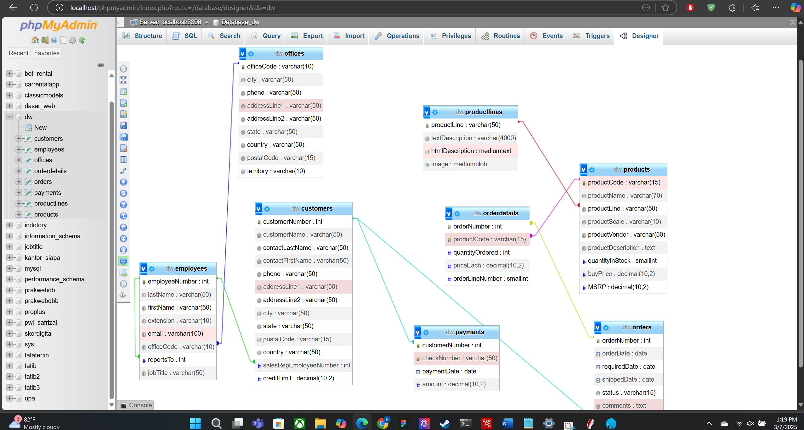

[SELECT](http://localhost/phpmyadmin/url.php?url=https://dev.mysql.com/doc/refman/8.0/en/select.html) * FROM employees employe, employees manager, customers cust WHERE employe.reportsTo=manager.employeeNumber [AND](http://localhost/phpmyadmin/url.php?url=https://dev.mysql.com/doc/refman/8.0/en/logical-operators.html%23operator_and) employe.employeeNumber=cust.salesRepEmployeeNumber;

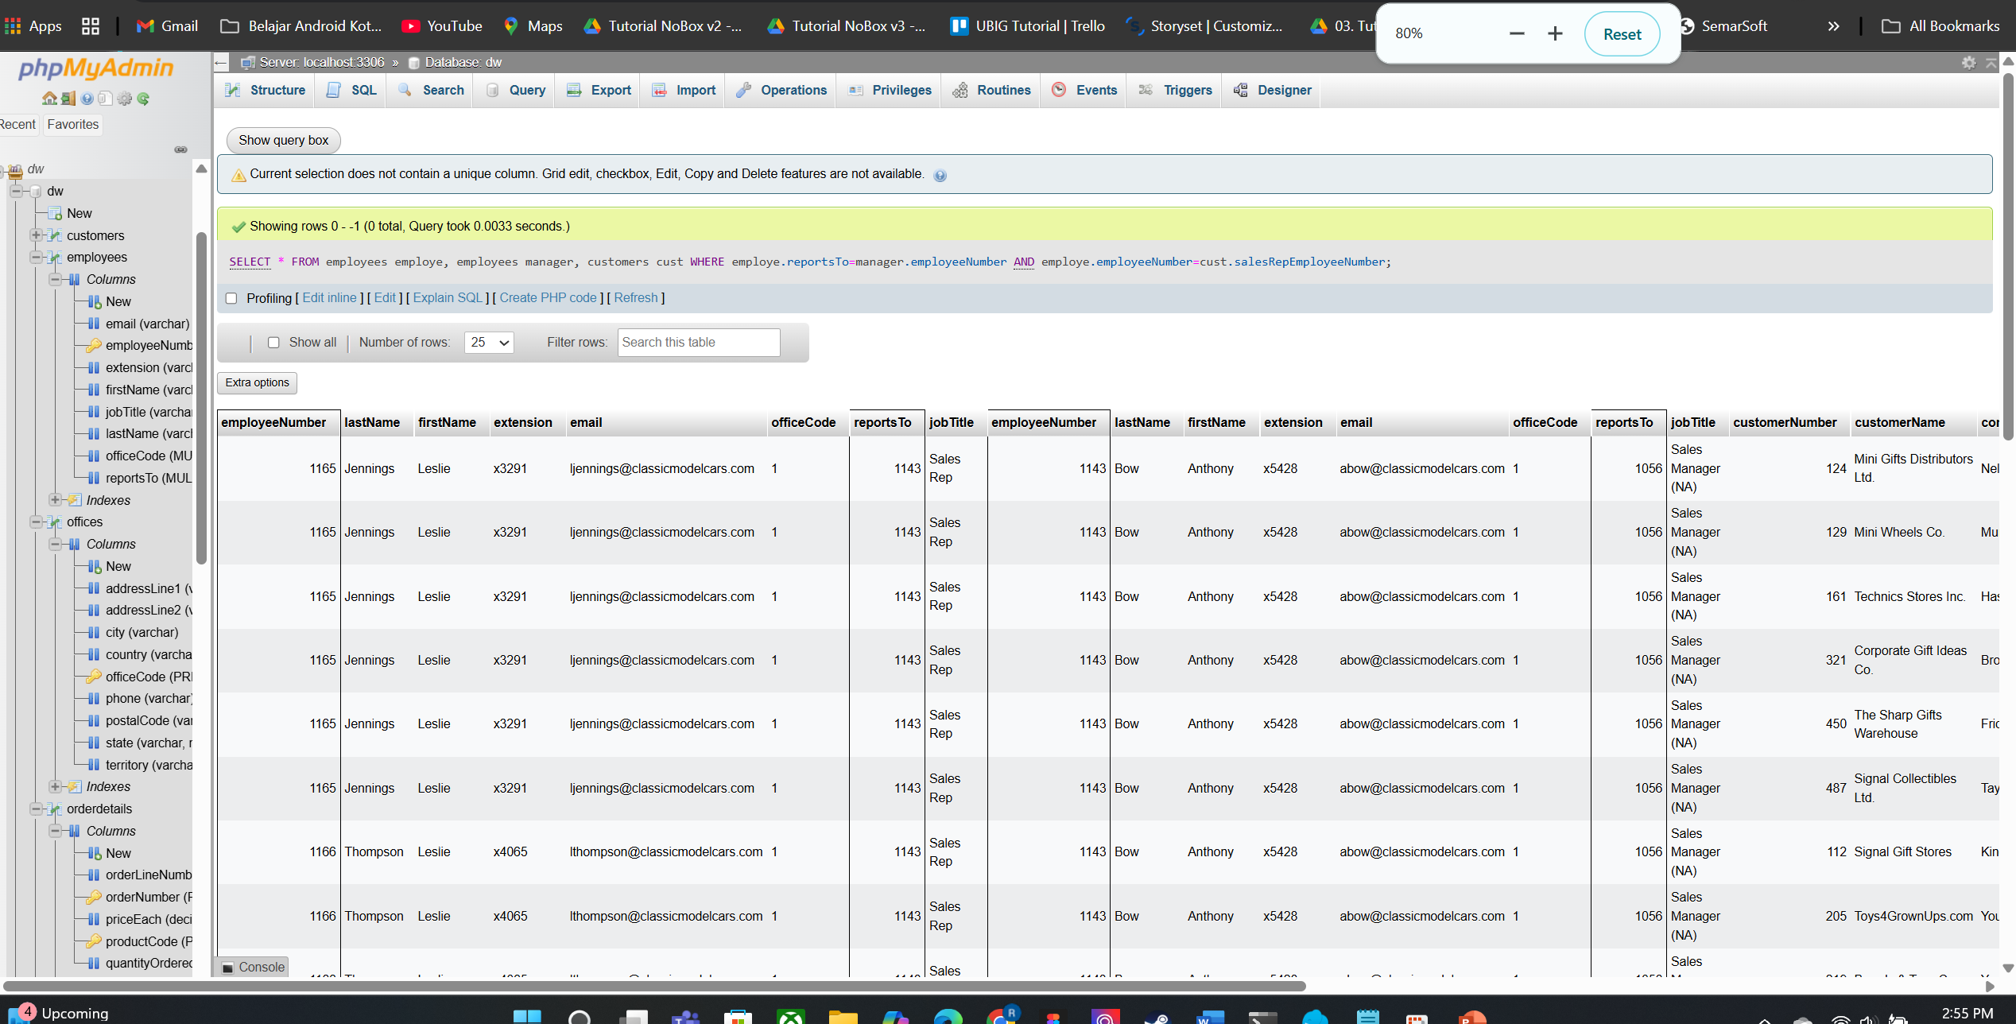

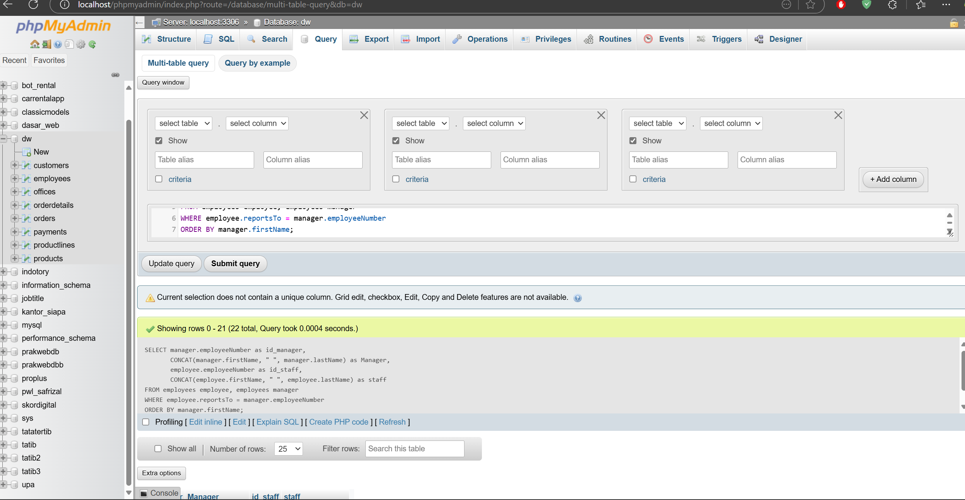

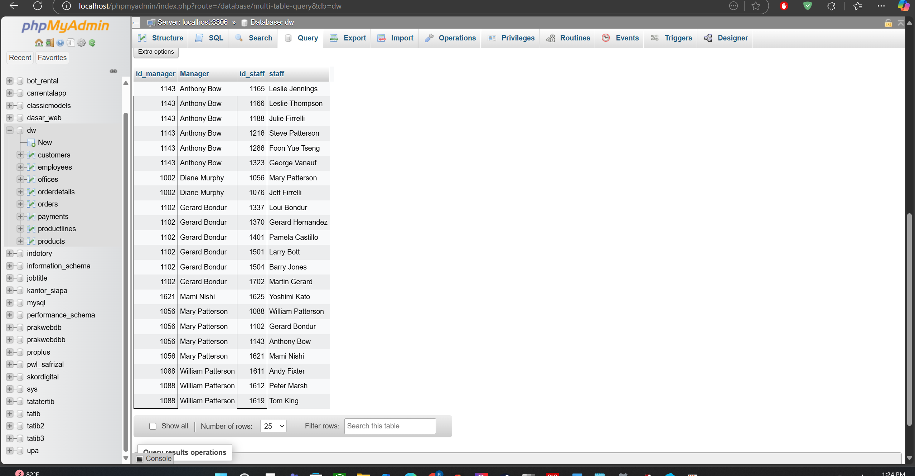

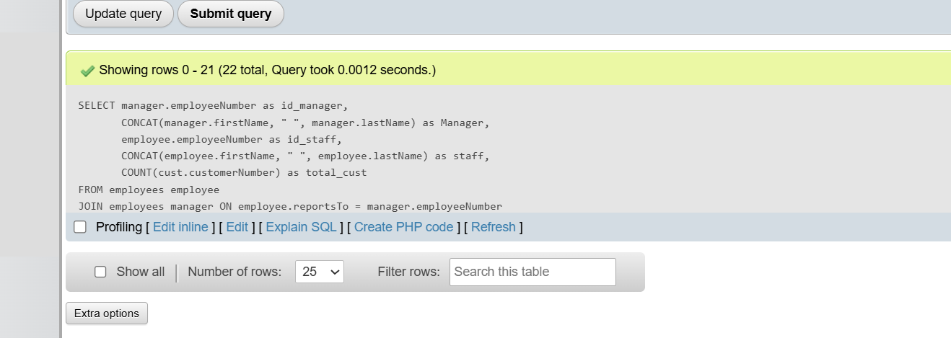

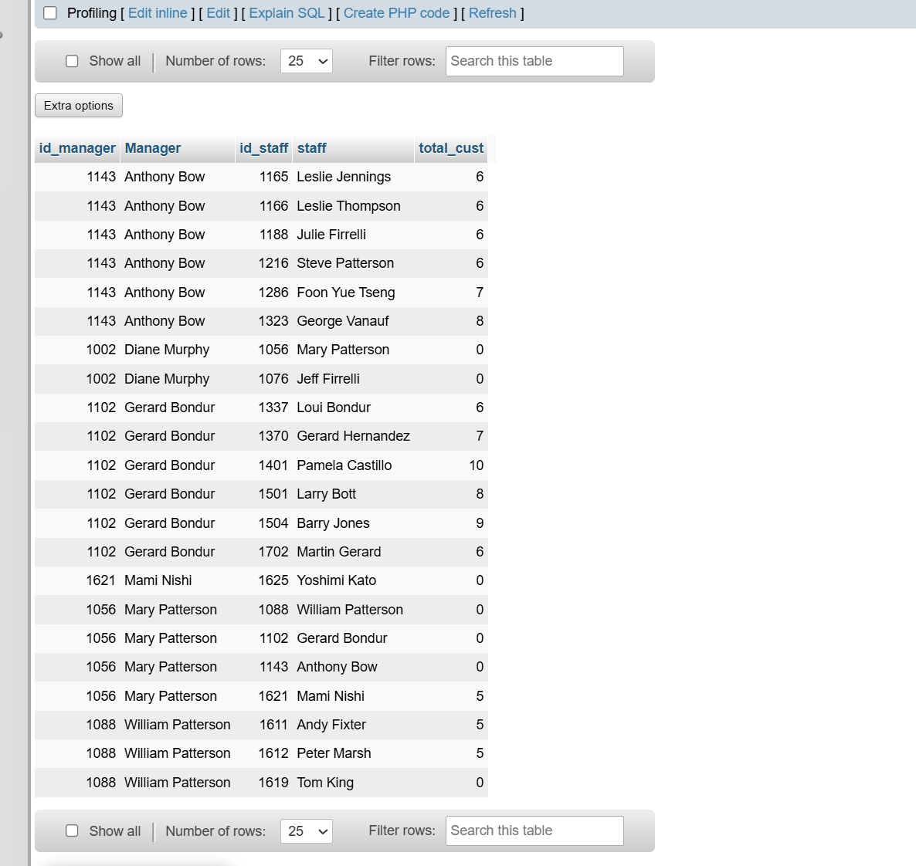

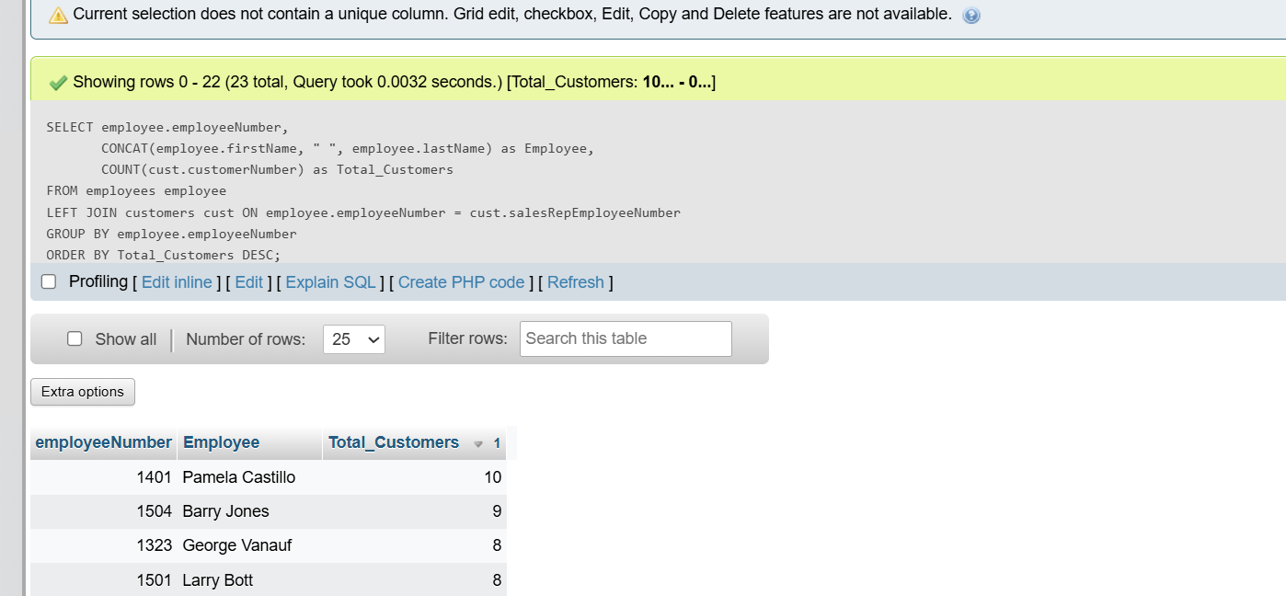

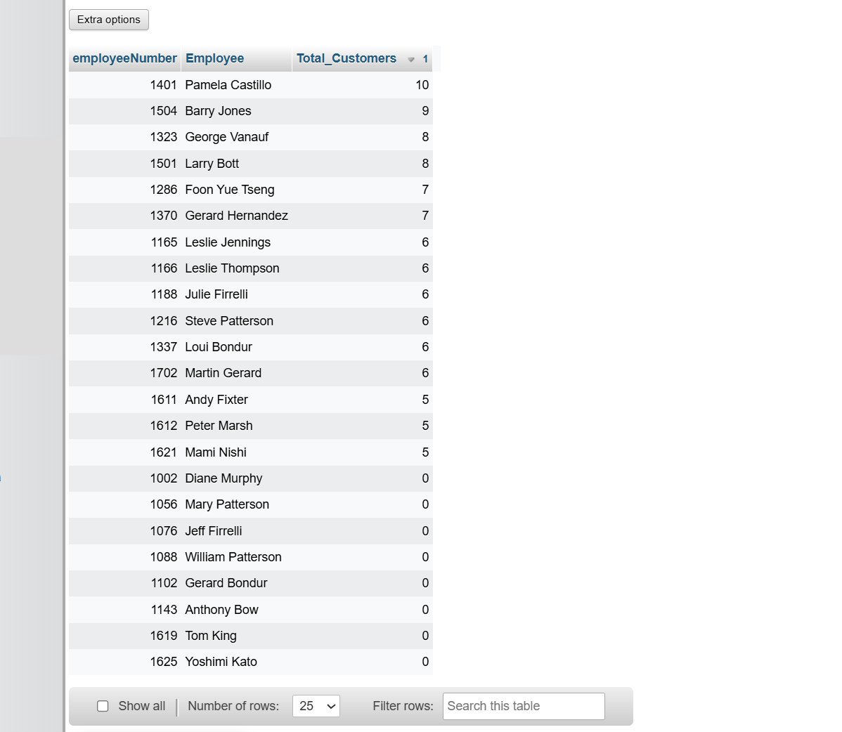

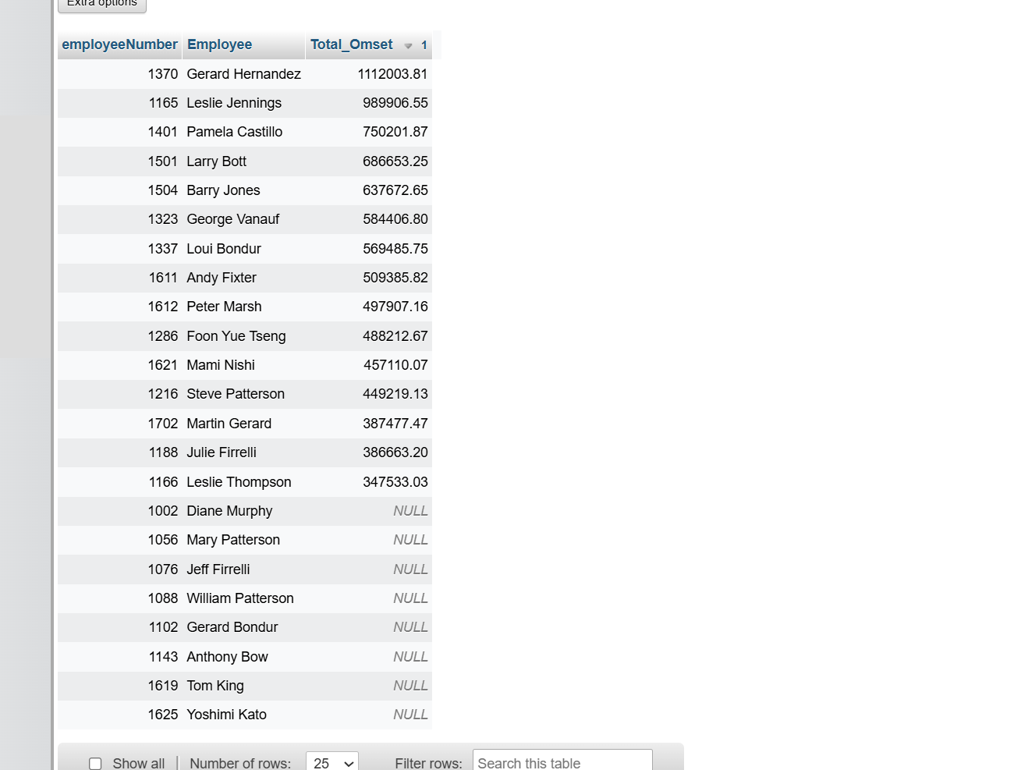

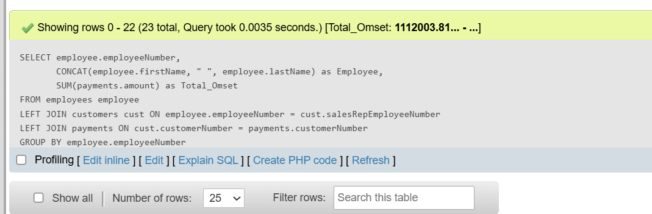  
  
  
  
  
  
  
  
  
**STUDI KASUS**

